The Table with the Input and Simulation results (Big table)
For this table we need a flexibility regarding the number of columns (number of parameters we display) and the order of the parameters. We also need a flexibility which parameters we display in this table. For example having a simulation series with the Nutsche as filter type we need different default parameters in the table than the default parameters of for example rotary filters.

But all filter types have the same equations (see all equations below)

Default Parameters for the table when selecting Nutsche Filter as Filter type

Nr. | SimSeries | Sim | Suspension | Filter medium | Machine Name | Filter Area/m2 | Δp  bar | Msus  kg | Vsusl | hc  mm | Tf  s

Mf  kg | Mcake  kg | Ms  kg | Qmsus  Kg/h | Qsus  l/h | Qmf  Kg/h | Qf  l/h | Qmcake  Kg/h | Qms  Kg/h | msus  kg/m2 | mf  kg/m2 | mcake  kg/m2

ms  kg/m2 | qmsus  kg/(m2 h) | qsus  l/(m2 h) | qmf  kg/(m2 h) | qf  l/(m2 h) | qmcake  kg/(m2 h) | qms  kg/(m2 h)

What is the Default Table for the continuously working filters (for example rotary filters)

Nr. | SimSeries | Sim | Suspension | Filter medium | Machine Name | Filter Area/m2 | Dp/bar | n | tc | sf | tf

hc | Qmsus | Qsus | qms

For the units of the above table please see the listing of all parameters below.

In the following we have a listing of all numerical parameters which have to be entered or/and calculated:

Nr. | Parameter | Unit (SI) | Unit Default | Name | Input (i) / Calculated (c) | Default | Equation
1 | A | m² | m² | Filter area | i/c | i | 27-12-11  28-11  29-12-11
2 | Δp | Pa | bar | Pressure Difference | i/c | i | 1
3 | n | s⁻¹ | min⁻¹ | Cycle frequency | i/c | i | 9
4 | tc | s | s | Cycle time | i/c | c | 10
5 | sf | - | % | Specific cake formation time | i | i
6 | tf | s | s | Cake formation time | i/c | c | 1
7 | hc | m | mm | Cake height | i/c | i | 2
8 | Vsus | m³ | l | Suspension volume for one cycle | i/c | c | 11
9 | Msus | kg | kg | Suspension mass for one cycle | i/c | c | 12
10 | Mf | kg | kg | Filtrate Mass | c | c | 14
11 | Vf | m³ | l | Filtrate volume | c | c | 13
12 | Mcake | kg | kg | Cake mass | c | c | 15
13 | Vcake | m³ | l | Cake volume | c | c | 16
14 | Ms | kg | kg | Solids mass | i/c | c | 17
15 | Vs | m³ | l | Solids volume | c | c | 18
16 | vsus | m³/m² | m³/m² | Area specific suspension volume | c | c | 19
17 | msus | Kg/m² | Kg/m² | Area specific suspension mass | c | c | 20
18 | mf | Kg/m² | Kg/m² | Area specific filtrate mass | c | c | 22
19 | vf | m³/m² | m³/m² | Area specific filtrate volume | c | c | 21
20 | mcake | Kg/m² | Kg/m² | Area specific cake mass | c | c | 23
21 | vcake | m³/m² | m³/m² | Area specific cake volume | c | c | 24
22 | ms | Kg/m² | Kg/m² | Area specific solids mass | c | c | 25
23 | vs | m³/m² | m³/m² | Area specific solids volume | c | c | 26
24 | Qmsus | Kg/s | Kg/h | Suspension mass flow rate | i/c | c | 27
25 | Qsus | m³/s | l/h | Suspension volume flow rate | i/c | c | 28
26 | Qms | Kg/s | Kg/h | Solids mass flow rate | i/c | c | 29
27 | Qs | m3/s | l/h | Solids volume flow rate | c | c | 30
28 | Qmf | Kg/s | Kg/h | Filtrate mass flow rate | c | c | 31
29 | Qf | m³/s | l/h | Filtrate volume flow rate | c | c | 32
30 | Qmcake | Kg/s | Kg/h | Cake mass flow rate | c | c | 33
31 | Qcake | m³/s | l/h | Cake volume flow rate | c | c | 34
32 | qmsus | Kg/(m² s) | Kg/(m² h) | Specific suspension mass flow rate | c | c | 35
33 | qsus | m³/(m² s) | m³/(m² h) | Specific suspension volume flow rate | c | c | 36
34 | qms | Kg/(m² s) | Kg/(m² h) | Specific solids mass flow rate | c | c | 37
35 | qs | m³/(m² s) | m³/(m² h) | Specific solids volume flow rate | c | c | 38
36 | qmf | Kg/(m² s) | Kg/(m² h) | Specific filtrate mass flow rate | c | c | 39
37 | qf | m³/(m² s) | m³/(m² h) | Specific filtrate volume flow rate | c | c | 40
38 | qmcake | Kg/(m² s) | Kg/(m² h) | Specific cake mass flow rate | c | c | 41
39 | qcake | m³/(m² s) | m³/(m² h) | Specific cake volume flow rate | c | c | 42
40 | Pc0 | m² | (10⁻¹³ m²) | Cake permeability for Dp=1 bar | i/c | i/c
41 | rc0 | m⁻² | (10⁺¹³ m⁻²) | Cake resistance for Dp=1 bar | i/c | i/c
42 | a0 | m/kg | (10⁺¹⁰ m/kg) | Cake resistance for Dp=1 bar | i/c | i/c
43 | nc | - | - | Cake compressibility | i | i
44 | ε0 | - | % | Cake porosity for Dp=1 bar | i | i
45 | ne | - | - | Cake Porosity factor | i | i
46 | hce | m | mm | Filter medium resistance | i/c | i/c | 6
47 | Rm | m⁻¹ | (10⁺¹⁰ m⁻¹) | Filter medium resistance | i/c | i/c | 6

Equations:

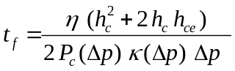 (1)

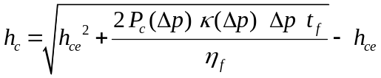 (2)
Please calculate also Δp=f(hc, tf) from (1)

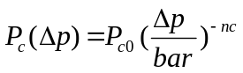 (3)

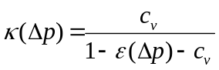 (4)

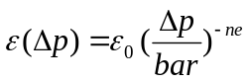 (5)

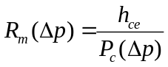 (6)

rc(Δp)=1/Pc(Δp) (7)

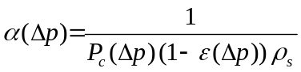 (8)
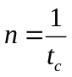 (9)
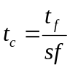 (10)

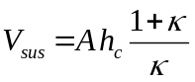 (11)
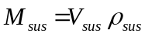 (12)

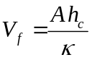 (13)
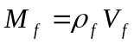 (14)

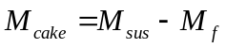 (15)
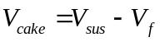 (16)

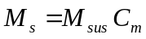 (17)
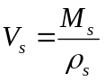 (18)

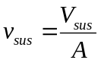 (19)
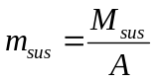 (20)

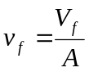 (21)
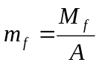 (22)

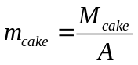 (23)
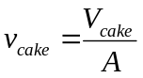 (24)

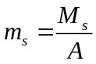 (25)
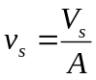 (26)

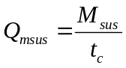 (27)
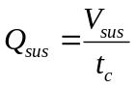 (28)

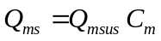 (29)
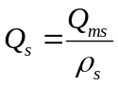 (30)

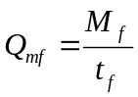 (31)
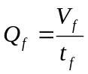 (32)

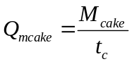 (33)
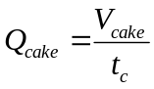 (34)

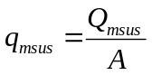 (35)
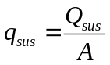 (36)

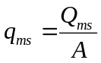 (37)
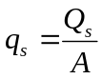 (38)

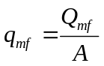 (39)
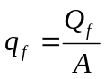 (40)

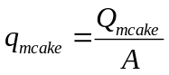 (41)
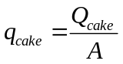 (42)

